

Bangladesh University of Business and Technology

PROJECT PROPOSAL ON

AIRLINE RESERVATION SYSTEM

Submitted By:

Yasir Rabbani Tanvir

ID: 21224103083

Raihan Sheikh Joy

ID: 21224103184

Sarjid Mia

ID: 21224103143

Pervej Khandakar

ID: 21224103050

Submitted To:

M.M.Fazle Rabbi

Assistant Professor

Dept. of CSE, BUBT

DATE: 14-11-2023

**Abstract**

At MA Tours and Travels, we're making booking your trips easier and safer. You might have used systems like Travelport or Galileo before but we noticed they can be a bit tricky and not always up-to-date. That's why we're creating something new! We're using Java and MySQL to build a system that's super easy to use, updates info quickly and makes sure your bookings are safe. Picture a world where planning your trips is simple and stress-free – that's what we're aiming for. Our goal is to make your travel experience smoother and faster. So, come along on this journey with us, and let's make MA Tours and Travels your go-to place for easy and secure travel plans!

**Table of Contents**

1. Introduction 3

2. Existing Model 3

3. Problem Statement 3

4. Objective of the Project 3

5. Existing System Analysis 4

6. Features / Scopes of Proposed System 4

7. Development Model 4

1. Data Flow Diagram (DFD): 6
2. Use Case Diagram: 7
3. Entity Relationship Diagram (ERD): 8

8. Solution Overview 8

9. Requirements 9

10. Activity and Time Schedule 9

11. Conclusions 10

# 1. Introduction

We all use airplanes to go from one place to another. To book our flights, we use computer systems. This project is about creating a better computer system for booking flights. We will use Java and MySQL to do this. The new system will be easier to use, show flight information in real-time and be safer for everyone.

# 2. Existing Model

Right now, the computer systems we use for booking flights like Travelport, Galileo are okay, but they have some problems. They can be a bit hard to use, and sometimes they don't show the most up-to-date flight information. Also, they may not be very safe from hackers. With this project, we want to make these systems better by using Java and MySQL to create one that is easier to use, updates flight information quickly and is very safe.

# 3. Problem Statement

The issues with the current flight booking systems are quite clear. People often find it hard to use them because the buttons and menus can be confusing. Sometimes, the flight information they show is not the most current, so travelers might not know if a flight is available or not. There's also the issue of safety - sometimes, personal information can be at risk. Another problem is that airlines might sell too many tickets or not enough, which can lead to problems for everyone. We want to fix all these issues and make booking flights much easier and safer.

# 4. Objective of the Project

Our main goal is to create a better flight booking system. This new system will always show the most up-to-date flight information. It will also be easy to use, so anyone can book a flight without any trouble. For airlines, it will be much better at managing how many tickets are sold, so there are no problems. This will make booking flights much better for travelers and help airlines work smoothly.

# 5. Existing System Analysis

We've looked at the current flight booking systems. Some things about them are good, but others are not so good. With this project, we want to take the good things and make them even better. We also want to fix the not-so-good things to make booking flights a better experience for everyone.

# 6. Features / Scopes of Proposed System

The new system we want to build will have some great features. It will always show the most recent flight information, so travelers will know exactly when they can fly. It will be easy to use, with simple buttons and menus. It will also keep all the information very safe, so nobody's personal data is at risk. Travelers will be able to search for flights easily and find what they need. This new system will make booking flights a breeze for everyone.

# 7. Development Model

We use Agile for this project because it offers several advantages that align well with the needs of MA Tours & Travels:

* **Customer-Centric Approach:** Agile focuses on customer collaboration and continuous feedback. This ensures that the developed system meets the specific needs and expectations of MA Tours & Travels, leading to a more satisfying end product.
* **Adaptability to Changes:** In the travel industry, requirements can change frequently. Agile allows us to be flexible and adapt to evolving needs, ensuring that the system remains up-to-date and responsive throughout its development.
* **Incremental Development:** Agile's iterative approach allows us to deliver working software in short phases. This enables MA Tours & Travels to start utilizing the system sooner and provide feedback for continuous improvement, enhancing the system's overall effectiveness.
* **Continuous Testing and Quality Assurance:** Agile places a strong emphasis on continuous testing throughout the development process. This ensures that the airline reservation system will be robust, secure, and of high quality, providing a reliable platform for MA Tours & Travels and their customers.
* **Collaboration and Communication:** Agile promotes close collaboration between the development team and stakeholders. Regular meetings and effective communication channels keep everyone informed about the project's progress, fostering a strong sense of teamwork and shared responsibility.
* **Faster Time-to-Market:** Agile incremental delivery approach enables us to swiftly deliver core features, accelerating the system's time-to-market. This allows MA Tours & Travels to start benefiting from the system sooner and gain a competitive advantage in the travel industry.
* **Risk Mitigation:** Agile facilitates early identification and mitigation of potential risks. By proactively addressing challenges, we can minimize the likelihood of encountering major obstacles during the development process, ensuring a smooth and successful implementation.

By leveraging the Agile methodology, we aim to deliver a successful and user-friendly airline reservation system that meets MA Tours & Travels' unique requirements while enhancing their operational efficiency and customer experience.

## Data Flow Diagram (DFD):

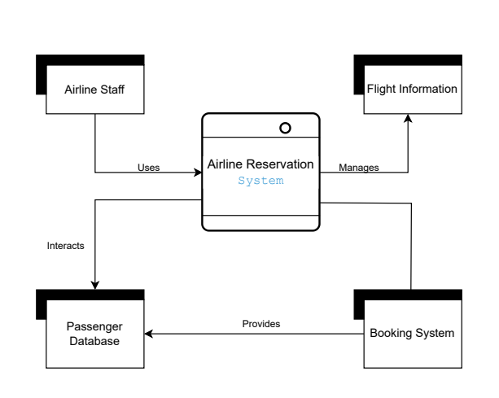

## b. Use Case Diagram:

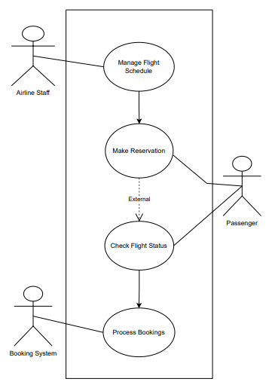

## Entity Relationship Diagram (ERD):

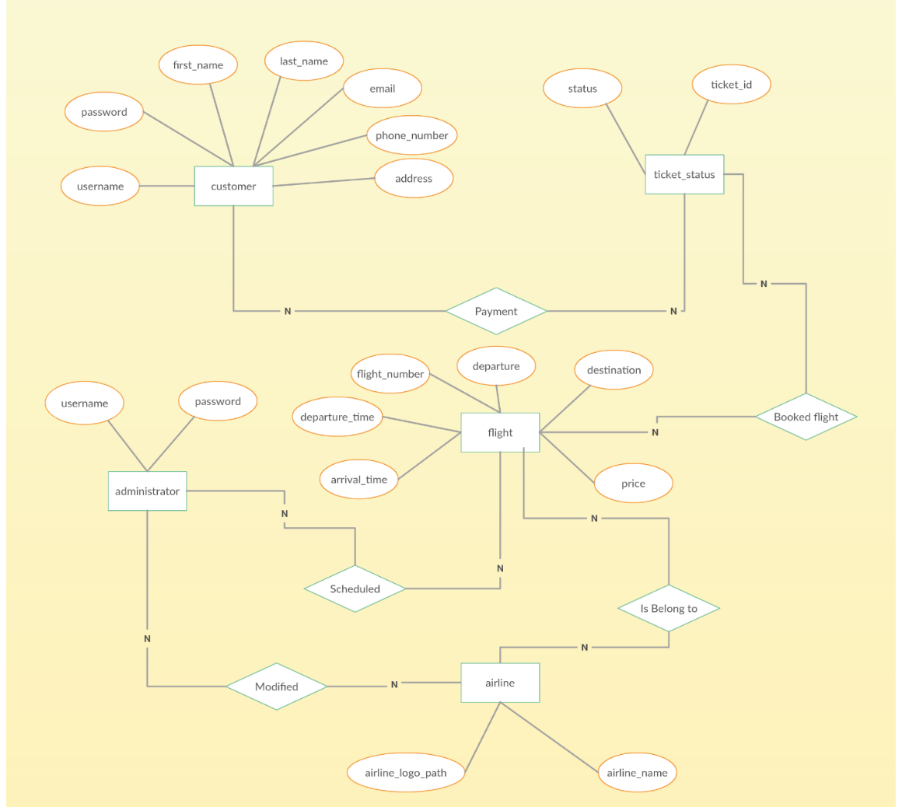

# 8. Solution Overview

In this part, we'll explain how the new system will work. There are two main parts: one that travelers see (the front-end) and one that stores information (the back-end). The front-end will be easy to use, so travelers can book flights without problems. The back-end will keep all the information safe and working well.

# 9. Requirements

To make this project happen, we need a few things:

**Hardware Configuration:** This means we need good computers and servers to run the system smoothly.

**Software**: We will use special computer programs, like Java and MySQL, to build the system.

**Personnel:** We need a team of experts who know how to use Java and MySQL. They will help create and test the system.

**Tools and Technology:** We will also use special tools to show real-time flight information and keep payment information safe.

**Programming Language:** For the part travelers see, we will use Java because it's great for creating simple and easy-to-use things.

# 10. Activity and Time Schedule

We'll make a plan for the project, dividing it into different steps and we need total **14 weeks** to complete this project.

**Requirements Analysis:** We'll start by learning what we need to do and planning the project in 1 week.

**Database Design and Development:** We'll create a plan for how information is stored and build a database in 2 weeks.

**Front-end Development:** We'll design the part travelers use to book flights in 4 weeks.

**Back-end Development:** We'll create the part that stores information and connects everything together in 4 weeks

**Testing and Debugging:** We'll check the system carefully to make sure it works well and fix any problems we find in 2 weeks.

**Deployment and Maintenance:** Finally, we'll make the system live for everyone to use and keep it working well over time in 1 week.

# 11. Conclusions

In summary, this project is all about making it easier and safer for everyone to book flights. We'll use Java and MySQL to build the system, making sure it's easy to use and keeps all information safe. This project will help travelers book flights without any trouble and help airlines work more smoothly. It's an important project for everyone involved in booking flights.